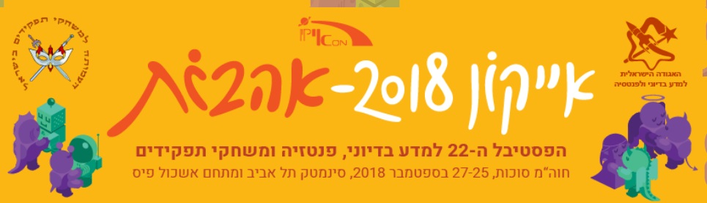
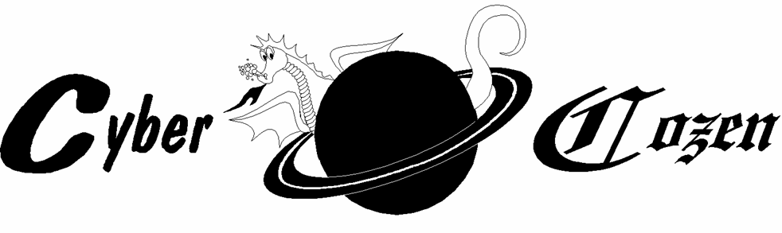
SCIENCE-Fiction Fanzine Vol. XXX, No. 08; August 2018

GET READY FOR ISRAEL’S ANNUAL SF&F ICON FEST: SEPT 25-27

The Israeli Society for Science Fiction and Fantasy חדשות האגודה – אוגוסט 2018
- המועדון בירושלים יעסוק בספר "פיקניק בשולי הדרך" מאת ארקדי ובוריס סטרוגאצקי (כנרת-זמורה-ביתן, 1999). המועדון יתקיים ביום שלישי, 28.8, בשעה 20:30. כתובת מדויקת תינתן לנרשמות ולנרשמים למועדון (ובפייסבוק). מנחה: אלה גורדון חן.
- המועדון בת"א יעסוק בספר "צד שמאל של החושך" מאת אורסולה לה-גווין שהלכה לעולמה בינואר האחרון (ינשוף, 2005, יצא גם ב-1978 בהוצאת "עם עובד" תחת השם "מעבר לעלטה"). המועדון יתקיים ביום חמישי, 30.8, בשעה 19:30. כתובת מדויקת תינתן לנרשמות ולנרשמים למועדון. מנחה: הדס זעירא.
המועדון בחיפה יעסוק בספר בספר "יושרה שניונית" מאת אן לקי, אורחת הכבוד של אייקון הקרוב (סיאל, 2015). המועדון יתקיים ביום חמישי, 16.8, ב-19:00, בבית פרטי ברחוב אבא הלל סילבר, חיפה. כתובת מדויקת תינתן לנרשמות ולנרשמים למועדון. מנחה: טניה חייקין.
המועדון הגליל מערבי בכרמיאל-משגב. ביום שלישי 14.8 יתקיים מפגש על הספר "לב "לב המעגל" מאת קרן לנדסמן (כנרת-זמורה-ביתן, 2018). ביום רביעי 5.9 יתקיים מפגש על הספר "יושרה שניונית" מאת אן לקי, אורחת הכבוד של פסטיבל אייקון 2018 (הוצאת סיאל, 2015). שני המפגשים יתקיימו בשעה 20:00, בבית פרטי במשגב. כתובת מדויקת תינתן לנרשמות ולנרשמים. מנחה: קרן פייט
ספרי החודש ספטמבר:
במהלך חודש ספטמבר יתקיימו מפגשים של המועדון במסגרת כנס אייקון בת"א: מפגש על הספר "יושרה שניונית" מאת אן לקי, אורחת הכבוד של אייקון (סיאל, 2015), ביום רביעי, 26.9 בשעה 10:00. מנחה: שירה אבנת.
מפגש על הספר "אשתו של הנוסע בזמן", מאת אודרי ניפנגר, לכבוד נושא הכנס "אהבות", ביום ד' 26.9 בשעה 20:00. מנחה: דפנה קירש.
הכניסה חופשית!
כל האירועים של האגודה מופיעים בלוח האירועים (שפע אירועים מעניינים, הרצאות, סדנאות, מפגשים ועוד)
לקבלת עדכונים שוטפים על מפגשי מועדון הקריאה ברחבי הארץ ניתן להצטרף לרשימת התפוצה או לדף האגודה בפייסבוק. Society information is available (in Hebrew) at the Society’s site: http://www.sf-f.org.il

This month’s roundup:
- Tribute to Harlan Ellison (1934-2018)
- Special contribution by William McCabe, England – on SF Urban Legends/Myths
- Alas, no “Sheer Science” this month – hopefully, something dedicated, next time
– As usual, interesting tidbits from various websites.
– Your editor, Leybl Botwinik

Creative Comments Column:
Dear Leybl:

That last item in the July '18 was a real eye open-opener -- about the proposed Space Force.
I almost missed the tiny link at the bottom, however -- thinking that, since Part 1 appeared in this issue, the others would follow suit in subsequent ones. The writer presented broad, thought-provoking ideas and points that will undoubtedly effect our near future on Earth and in outer space. Thank you for bringing in such original, unusual material!
Gary R.
(And Tardy Tales about the June issue)
Good (a) morning, (b) afternoon, (c) evening, or (d) none of the above, Leybl.

Seriously, I am not sure what time of the day it is where you are in Israel, but I suspect it's late afternoon right now. Where I am, it is currently 9:40 AM and I am on my second cup of coffee. So with java in hand, some quick comments on the latest issue.

Thank you for printing my loc. Like I said, no one is really sure if Joel Hodgson, the perpetrator of MST3K ever attended Minneapolis science fiction conventions back in the day, but there is no question that he is a fan of sf movies, the more ludicrous endeavours, the better.

As usual, you provide interesting little articles with links to their larger versions. The ones I find the most interesting are the "Cloudless Exoplanet" and the "Fizzy Beer" article. Regarding the former, I find it fascinating that astronomers made this conclusion, and since clouds form from moisture in the air, usually sucked up from a planet's surface, then we could conclude that this exoplanet orbiting WASP-96b has no oceans; in fact, its bone dry. Odds are there are no lifeforms, as we know it there.

As for the "Fizzy Beer" scene from The Expanse, I remember that episode quite well. I remember wondering, "how the heck did they do that?" when seeing it the first time, so reading the link accompanying this article was really interesting. Let's hear it for Getting It Right in science fiction movies and television programs. No wonder I enjoy this show so much.

The review of John Scalzi's 2006 novel The Android's Dream is well written. This is one of Scalzi's I haven't yet read, and since I do enjoy his fiction, this goes on my To Be Read list. Since my public library card needs to be renewed, when I get that taken care of I shall check to see if our local library has a copy.

Well, that's it for now, Leybl. Thank you again for another interesting issue, and I look forward to the next one.

All the best,

John P. Texas

Some fun from the Websites:
Look up… way up …  Israel to Launch its First Mission to the Moon  By United with Israel Staff July 10, 2018  SpaceIL, an Israeli NGO, announced Tuesday it will be launching a spacecraft toward the moon at the end of 2018. The spacecraft is set to be launched using Elon Musk’s private aerospace company SpaceX, with a scheduled landing date on the moon of February 13, 2019.  The spacecraft, which will be the smallest ever to land on the moon, is expected to land roughly two months after leaving Earth, making Israel the fourth country in history to land a spacecraft on the moon, following Russia, the US, and China.  To read more, see: https://unitedwithisrael.org/israel-to-launch-its-first-mission-to-the-moon/ | And while we’re n the subject…  'Apollo 11' Film to Show First Moon Landing Like Never Before  By Robert Z. Pearlman, collectSPACE.com Editor | July 20, 2018  A new cinematic space event film promises to show audiences the historic Apollo 11 first moon-landing mission like they have never seen before.  "Apollo 11," from director Todd Douglas Miller, will feature never-before-seen large-format film footage of the 1969 mission that landed astronauts Neil Armstrong and Buzz Aldrin on the surface of the moon. The feature-length documentary is executive produced by CNN Films and produced by Miller's Statement Pictures.  [NASA's Historic Apollo 11 Moon Landing in Pictures]  To read more, see: https://www.space.com/41230-apollo-11-moon-landing-film.html

A tribute to Harlan Ellison (1934-2018).
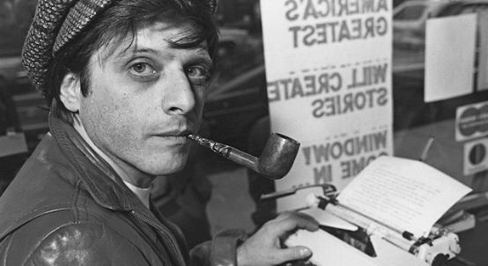
Wikipedia has: “His published works include more than 1,700 short stories, novellas, screenplays, comic book scripts, teleplays, essays, and a wide range of criticism covering literature, film, television, and print media. Some of his best-known work includes the Star Trek episode "The City on the Edge of Forever", A Boy and His Dog, "I Have No Mouth, and I Must Scream", and " 'Repent, Harlequin!' Said the Ticktockman", and as editor and anthologist for Dangerous Visions (1967) and Again, Dangerous Visions (1972). Ellison won numerous awards, including multiple Hugos, Nebulas, and Edgars.”

My friend Shlomo, wrote a great piece on this extraordinary writer. Here’s a lead-in:

Remembering Harlan Ellison: What He Meant to Me
FROM “CRITICS AT LARGE”: By Shlomo Schwartzberg film & entertainment critic, Toronto
I’ve been thinking a lot about writer Harlan Ellison, who passed away at 84, either on June 27 or June 28 – reports differ – reportedly in his sleep. That means he died on my 59th birthday or shortly thereafter, thus allowing me to mark a milestone of another sort, a recognition that his presence, as a cultural and personal influence, has been with me for more than 40 years, my having discovered him at age 15 or 16, when I was still in high school.
That’s longer than most of my friendships. (The only other writer I’ve read as deeply is Stephen King but it’s not the same type of relationship.) I am not sure exactly when I discovered him or which books of his I read first – though many of my copies of Ellison were the Pyramid editions with the artsy covers and his name in big bold letters at the top – but I know as soon as I did cotton onto Harlan Ellison, I almost became fixated on him.
I picked up his collections, of course, but pretty much bought any magazine that featured his name on it or anthologies to which he contributed. I also tried to catch him on TV, NBC’s Tomorrow (with Tom Snyder) and CBC’s 90 Minutes Live in those days, ABC's Politically Incorrect with Bill Maher later on, where he was scintillating, and I still recall how excited I was when CBC’s flagship radio show As It Happens chose to interview Ellison when Ronald Reagan was elected U.S. president in 1980.
Harlan wasn’t too happy about that event, as you can imagine, notably having been on the wrong side of the president when he was governor of California and put Ellison on his enemies’ list. Hell, I even joined Harlan Ellison’s fan club, which sent out neat booklets, extolling his latest projects and the like, and which I still possess. I’ve never done that for anyone before or since.
To continue reading this fascinating write-up, see:
https://www.criticsatlarge.ca/2018/07/remembering-harlan-ellison-what-he.html

Editor’s NOTE:
Shlomo was so enthusiastic of Ellison, he lent me his copy of “Dangerous Visions” that I thoroughly enjoyed (and often still think about those stories) and he also sent me to see “A Boy and His Dog” (or possibly we went together). Ellison’s genius and powerful ideas will definitely be missed.

Special from William McCabe (who claims much of the facts were tracked down via Wikipedia. See, for example: https://en.wikipedia.org/wiki/First_interracial_kiss_on_television )

Myths, Urban Legends, and SF in Popular Culture
– Some thoughts by William McCabe, England

There is a lot of mythology about science fiction in popular culture. It’s supposed to be the sort of thing that breaks boundaries and does things first. The trouble is, it isn’t true as often as some people think.

In the last few weeks I’ve had someone repeat the old story of “Star Trek” having the “first inter-racial kiss” on TV. It’s one of those stories that has been repeated so often that you’d think people would have tried checking the story before they repeat it. It’s even worse because she said this here (in England) where the incident people usually think of regarding that statement is entirely irrelevant.

Of course, everything is open for debate. You have to first decide what a “race” is. If you think the Spanish and the Northern Europeans are of different races, you’d have to include Lucille Ball and husband on their regular TV show in the 1950s.

This happened so often, you’d have to work out which was first and, maybe, who did what to whom. The most obvious difference in race is the visual ‘extreme’: between black and white. Britain broke that boundary sometime around the end of the 50s/beginning of the 60s – twice in live broadcast plays shown late at night, then once in a popular early evening soap opera.

America didn’t manage that until an incident with Nancy Sinatra and Sammy Davis Jr. on her own TV show in 1967.

From Wikipedia: https://en.wikipedia.org/wiki/First_interracial_kiss_on_television
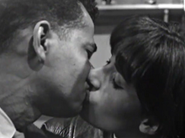
You in Your Small Corner, live broadcast on British television from 1962.
In June 1962, a live performance of the play You in Your Small Corner by Barry Reckord was broadcast on British television as part of the series Granada Play of the Week. The central theme of the play is a relationship between a young black intellectual and a white working class girl.

You might also consider “mixed race” actors and decide whether they qualify as either or neither of their relevant ancestors. There’s one on the TV show “I Spy” in 1966, between Robert Culp and France Nuyen (who is “Eurasian” – who also starred in Star Trek, and played “Elaan of Troyius” – also the title of that episode).

Surprisingly “Star Trek”’s big claim to fame comes from the “famous/notorious” kiss in the last series between William Shatner and Nichelle Nichols - in 1968. Nichols seems to bask in the glory but Shatner says he faked it.
It gets more ridiculous, when you consider the person making the claim [LB: “first inter-racial kiss”] was in this country. When the BBC first got the rights to “Star Trek” there was one episode they didn’t think suited the regular time slot they’d put it at (6-7 p.m.) and so they ran it after the “watershed” (9 p.m.). Viewer figures were dire for that episode.

They then got the last series which had been run in the U.S.A. at 10 p.m. and found 3 episodes weren’t suitable for the early evening slot. That included the one with the kiss. This time they didn’t even try to broadcast late at night and just didn’t run those episodes.

Over the years they retained the rights, and re-ran the show, but excluded the 4
“banned” episodes. In the 1990s digital TV was introduced, and “Star Trek” was sold to a different channel in the U.K. Although the BBC hadn’t run the show for years, they still had the rights to two more full runs.

Whoever it was that did the new scheduling either didn’t know or didn’t care about the “ban” and all 4 banned episodes were first run from the end of 1993.

Another old myth goes that “Star Trek” invented the mobile phone. This is particularly odd since “Star Trek” never really seemed to manage the telephone anyway. People talk to each other on little handsets that look like walkie-talkies without the aerial. They never seemed to have any buttons to press or anything like that, you just flip them open and you’re automatically connected to an operator.

It also turns out that the Americans had mobile phones before that. The TV show may have had something to do with the design of the flip phone (the sort of mobile that flipped open and had problems with the hinge and the connection across it if you did that too often) and they even made one to look like one of those old “Star Trek” walkie-talkies. Then again, the flip phone didn’t seem to be that popular.
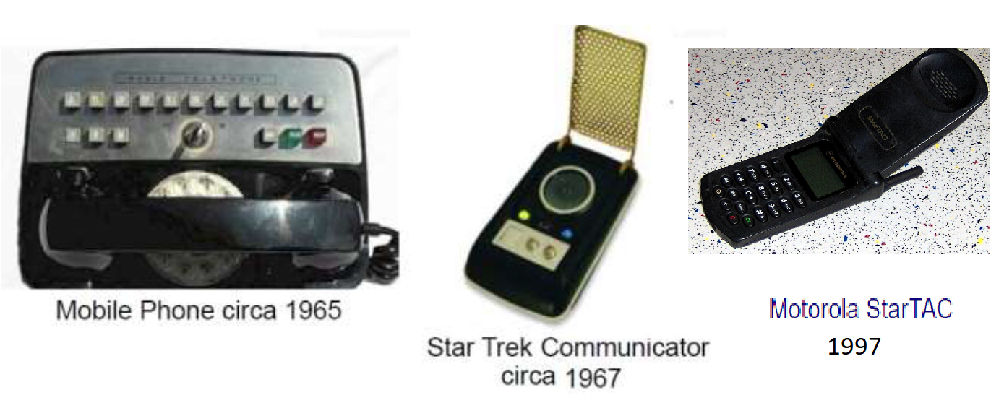
Is all this mythologizing just because the fans want to believe this stuff is really forward-looking and has an idea what it’s talking about, or maybe they just want to think it’s important. Are they really that insecure?

We’d love to hear your thoughts on the above topics and with your OK, we may publish them!

d
For Comments: E-mail: leybl_botwinik@yahoo.com. Tel: Leybl Botwinik +972-54-537-7729
Editor: Leybl Botwinik. Founding Editor: Aharon Sheer (ז"ל). Logo by: Miriam Ben-Loulu (ז"ל).
For free email delivery (PDF format) write to leybl_botwinik@yahoo.com
Copyright © 2018 — Archives at: http://www.kulichki.com/antimiry/cybercozen
Also (archived issues from 2014+) at: http://fanac.org/fanzines/CyberCozen/
And http://efanzines.com/CyberCozen/index.htm
All rights reserved to specified authors and artists © כל הזכויות שמורות למחברים וליוצרים

